**MONISHA.DUSANAPUDI**

**Phase 8 Report: Data Management & Deployment**

**Non-Profit Donation & Volunteer Management**

**Objective:** The objective of Phase 8 was to prepare the application for use by populating it with sample data and implementing critical data quality controls. This phase focused on using professional tools for bulk data operations, preventing data duplication, and formalizing the understanding of the deployment processes used throughout the project.

**1. Data Loader & Data Import**

* The **Salesforce Data Loader**, a client application, was successfully installed, configured, and used to perform a bulk data import. A sample CSV file containing five new volunteer records was prepared. Using Data Loader, a connection was authenticated to the Salesforce org, and an Insert operation was performed on the Contact object. The columns in the CSV file (FirstName, LastName, Email) were correctly mapped to their corresponding fields in the Contact object.

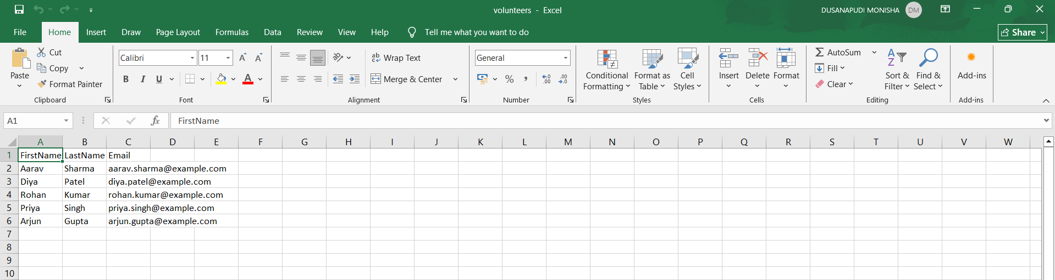

* **Verification:** The import was verified by navigating to the "All Contacts" list view within the application. The five new records (Aarav Sharma, Diya Patel, etc.) were present, confirming the Data Loader operation was a **100% success**

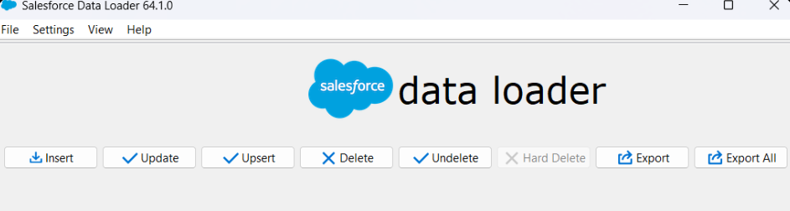

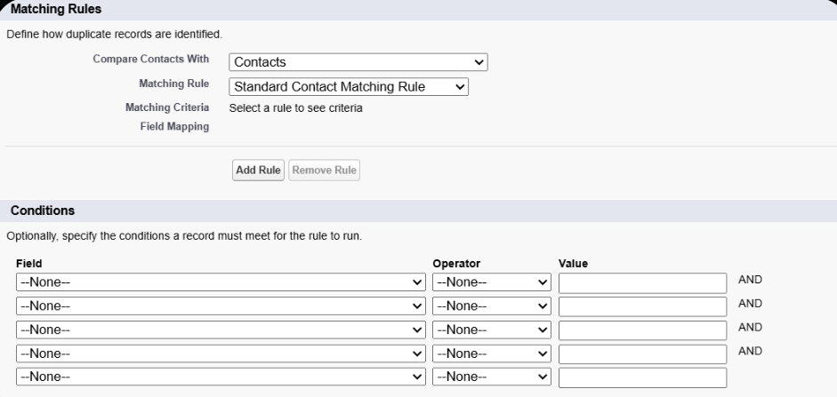

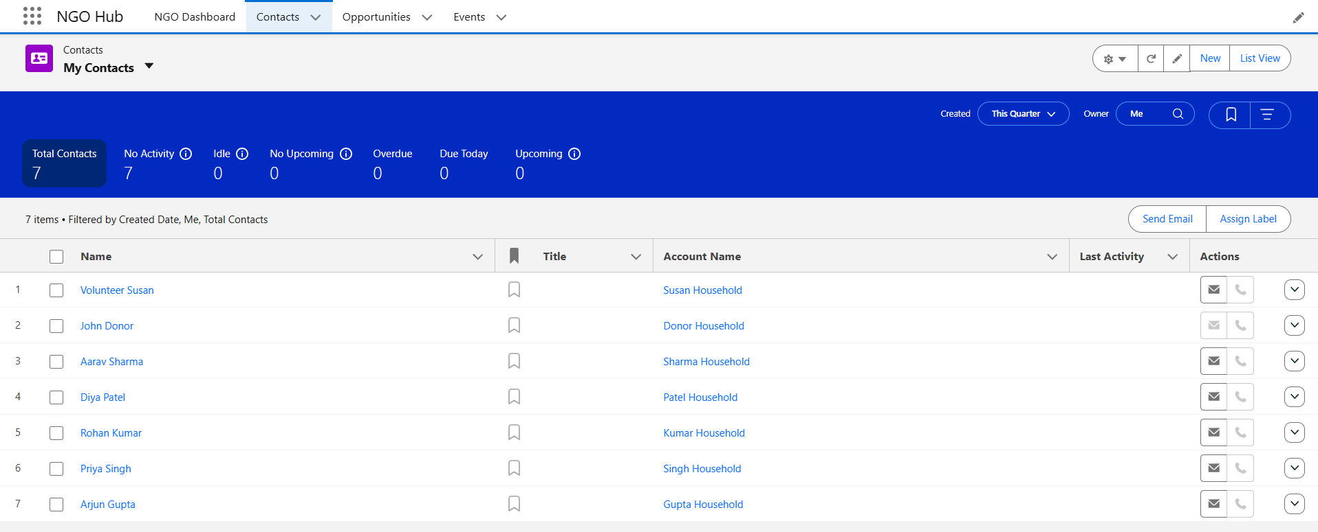

**2. Duplicate Rules: Ensuring Data Quality**

* A robust duplicate prevention mechanism was implemented. This involved a two-step process:
  1. A **Matching Rule** (Exact_Match_on_Email) was created to define how duplicates are identified, specifically by looking for an exact match on the Email field of the Contact object.

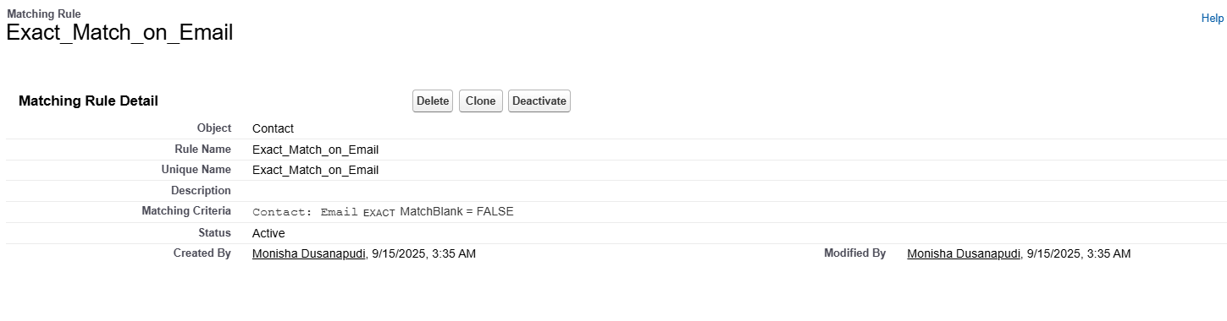

* 1. A **Duplicate Rule** (Block Duplicate Contacts by Email) was created and activated. This rule utilizes the matching rule and is configured to **Block** users from creating a new Contact record if a duplicate is found.
* **Verification:** The rule was tested by attempting to manually create a new Contact and entering an email address that was already in the system (aarav.sharma@example.com). The test was **successful** as Salesforce correctly blocked the save action and displayed a clear error message, proving the duplicate rule is functioning as designed.

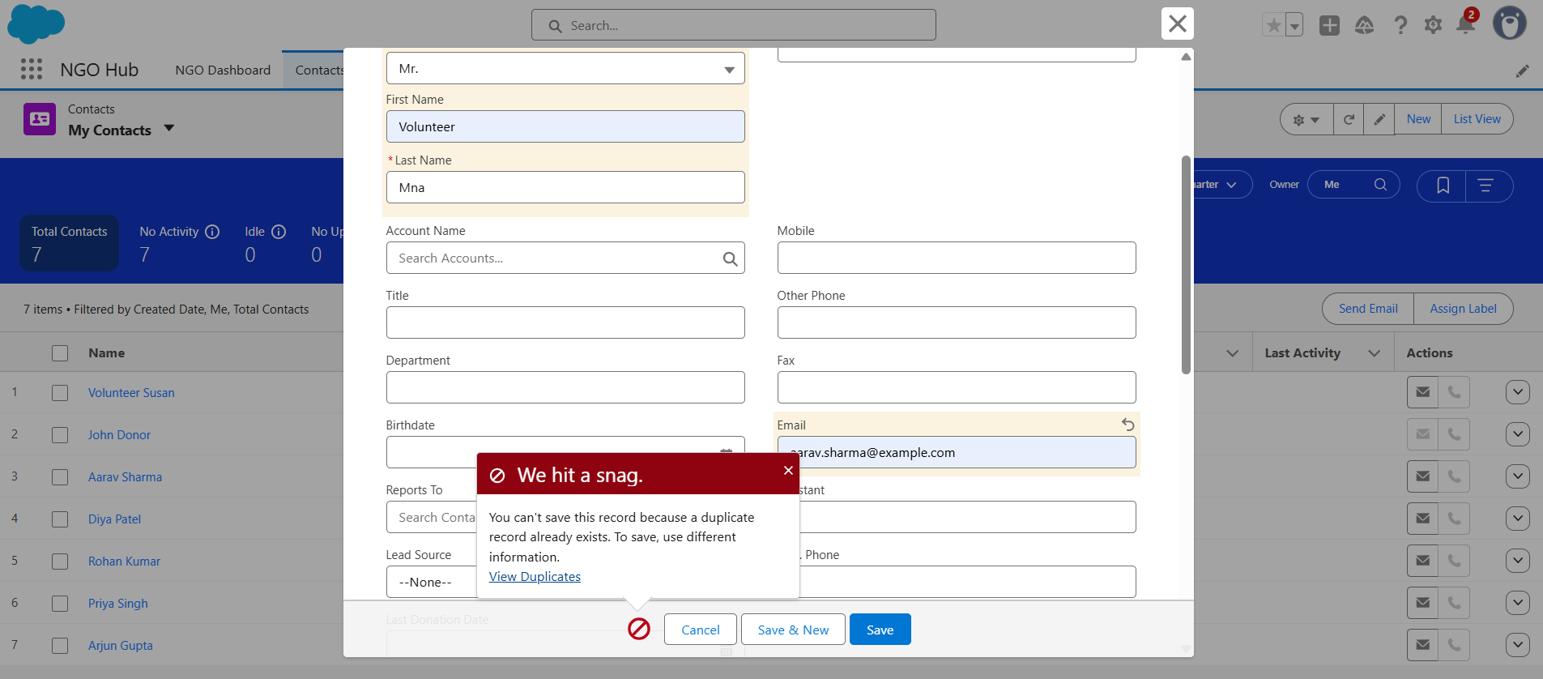

**3. Data Export & Backup**

* The standard Salesforce Data Export service, available within the Setup menu, was reviewed.

**4. Deployment (VS Code & SFDX)**

* primary method for moving customizations (**metadata**) throughout this project has been **Visual Studio Code and the Salesforce CLI (SFDX)**. All custom Apex code, Lightning Web Components, and their related configurations have been deployed using the SFDX: Deploy Source to Org command.

**Conclusion:** Phase 8 is successfully complete. The application has been populated with starter data using a professional tool, and a critical data quality rule has been implemented and tested. Furthermore, the modern deployment methodology used for all custom code has been formalized. The application is now not only functional but also prepared for scalable data management and a structured deployment lifecycle.